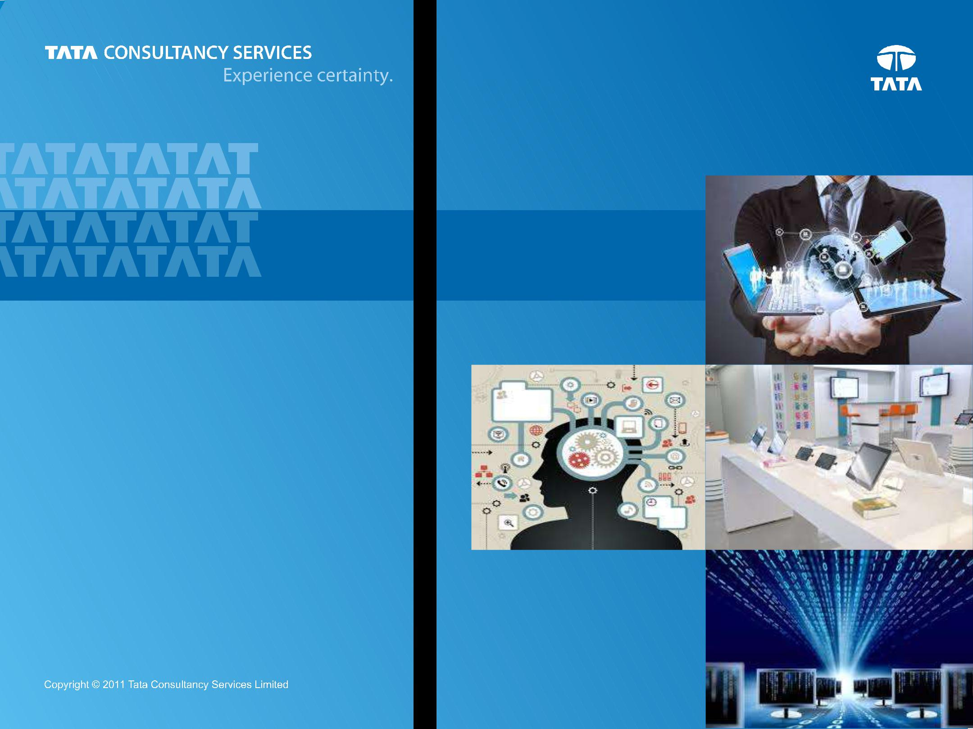

***Bank’s view of itself***

***Customer’s View of Bank***

**Digital Banking**

***Chapter 1 : Introduction***

**Prepared : October, 2014**

1

**Content**



**Introduction**



**Customer**



**Banking Digitally**



**Channel Transformation**



**Effects on Retail LoBs**



2



**Looking around us …**



* Interactive Grocery Stores in airports and Subways
* Movie Streaming, eBooks, Tablets
* 20% online sales from Smartphones
* 10 % of all orders of Tesco Direct from mobile website



* GM Partnership with RelayRides
* GM’s customer fleet & OnStar program; with entire experience enabled thru mobile app
* RelayRide’s Insurance for the

P2P car sharing marketplace



| Digital Life, an application and |  | Thru MagicBand | |  | Building cloud-based services with |
| --- | --- | --- | --- | --- | --- |
| services platform offering services |  | • | Tactical: Preferential Queue, |  | intelligent analytics to collect and |
| to consumer households including |  |  | Touch to Pay |  | combine vast amounts of |
| media management, home |  | • | Precognitive Servicing: Food |  | industrial-machine & equipment |
| security, home energy monitoring |  |  | pre ordering |  | data, extracting unique insights to |
| and diverse sensor-based services |  | • Socializing: Plans with friends | |  | set new performance standards in |
| such as water leak detection and |  |  | & family |  | major industries such as energy & |
| water main control |  | • | Experiential: Activity storybook |  | aviation |
|  |  |  |  |  |  |
|  |  |  |  | 3 | |



**.. and on a closer look**



* Interactive Grocery Stores in airports and Subways
* • Movie Streaming, eBooks,

**New Business Line**

• Tablets

**New Distribution Model**

• • 20%**Customers**onlinesales from

**“Like”**

Smartphones

* 10 % of all orders of Tesco Direct from mobile website

Digital Life, an application and services platform offering services

to consumer households including

• **Expanded Business Line**

media management, home

• **From Infra provider to a** security, home energy monitoring

**“Life Style partner”**

and diverse sensor-based services such as water leak detection and

water main control



Thru MagicBand

* Tactical: Preferential Queue, Touch to Pay
* • Precognitive Servicing: Food

**From Tactical to “TACTILE”**

• pre ordering

**Hyper Personalization &**

* Socializing: Plans with friends

**Hyper Localization**

& family

* Experiential: Activity storybook



* GM Partnership with RelayRides
* • **Disruption in existing**

GM’s customer fleet & OnStar

**business model** program; with entire

• **Symbiotic Relationship =** experience enabled thru

**Ecosystem** mobile app

* RelayRide’s Insurance for the

P2P car sharing marketplace

Building cloud-based services with intelligent analytics to collect and combine vast amounts of

industrial•-machine & equipment

**Harnessing the power of**

data, extracting unique insights to

**Information**

set• new performance standards in

**“Value Added Services “** major industries such as energy &

aviation

4

**Digital Banking**

***Broad range of technology (& sensor) centric capabilities enabling newer methods of multi modal, multi directional and insight driven interaction1 across the value network2 to augment customer experience and drive growth across ecosystem players - enabled via transformation of Processes, Delivery & Information sources***

| **Being Digital** |  | **Analog to Digital** |  | **Digitalization** |
| --- | --- | --- | --- | --- |
|  | **Processes** |  | (Digital Asset |
| (Electronification) |  |  |
|  | (Paperless) |  | Monetization) |
|  |  |  |
|  |  |  |  |  |



|  | ***Focus Areas*** | ***Key Watch outs*** | |
| --- | --- | --- | --- |
| **Customer** | **Content and** | **Ears on Market** | **Balancing Silo** |
| **versus** |
| **Identity** | **Data** | **Inputs** |
| **Enterprise** |
|  |  |  |
| **Access and** | **Location and** | **Value** | **Focal point** |
| **Assessment for** | **“on” the Value** |
| **Delivery** | **Context** |
| **(IT & Business)** | **Chain** |
|  |  |



| ***1: Engagement & Service Delivery*** | 5 |
| --- | --- |
| ***2 : Value Network = customer, government, retailers, network provider, regulator)*** |  |



**Gartner’s Taxonomy**

***Areas of significant changes include the ways products are consumed, services are delivered and revenue & costs are allocated***

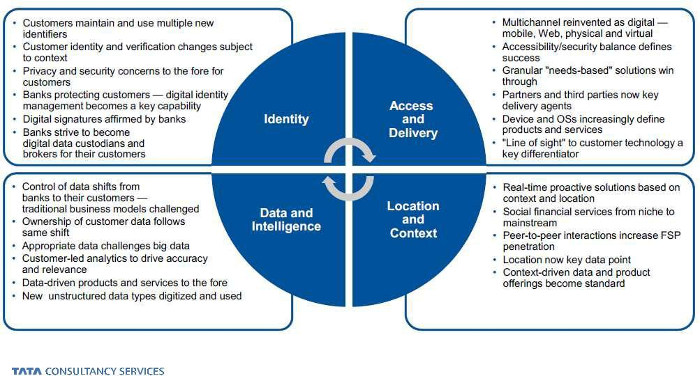

6

***Source : Gartner Aug 2013***

**Across Banking Functions : Macro view**



**Overarching : One Wells, One HNB, One Citi, New BAC, Chase 3.0**

**Lending & Mortgage** :Digitized On boarding (Self,

Salesforce), Instant

Wealth

Deposits

Lending, Real ManagementtimeRisk Profiling, 3rd party enabled

Cardsproperty& search,

Mortgage

Lending

Augmented Reality based

solutions

Payments

Channels

**Cards & Payment** :

Tokenization & Cloud based

Risk & Fraud Management

SE, Collection & Dispute

resolutionClearing& Settlementoverdigital

channels, Digital Wallets, Digital Offer ecosystem with self learning

**Wealth Management** :

Comm. Real

DepositsHNI(automated &

Estate

personalized) Research

CardsCapsule,& Portal for

Trade Finance

UnderstandingLending & buying Investment products,

Payments

Property Investment with

time machine style

Channels

visualization, MRDC into brokerageRisk&Fraudaccount,ManagementVirtual agents for periodic updates

Clearing & Settlement

& visual chat, Client & Product analytics

**Commercial Banking** :Funds Predict for corporate treasurer, Touch / SurfaceAsset

Brokerage

solutions for documentManagment digitization & workflow for

Trade Finance, SocialMarket

Custody

Infrastructure

Networking site, Business

Assist capabilities

Money Movement

**Investment Banking** :

Channels

Amazon like trade related

Riskrecommendations,&FraudManagementTxn

analysis for Trade Data

Clearing & Settlement

breaks, Portal & Reporting for investors & brokers, Market Reference Data (online, mobile)

**Channels**:

Video-mobile-tablet integration, Interaction Gamification, Sentiment analysis, Sensor based solutions, Early Engagement, Widgets in Social channels for transacting, Integrated workspace (biz apps, collaboration/messaging/blogs, directories)



7



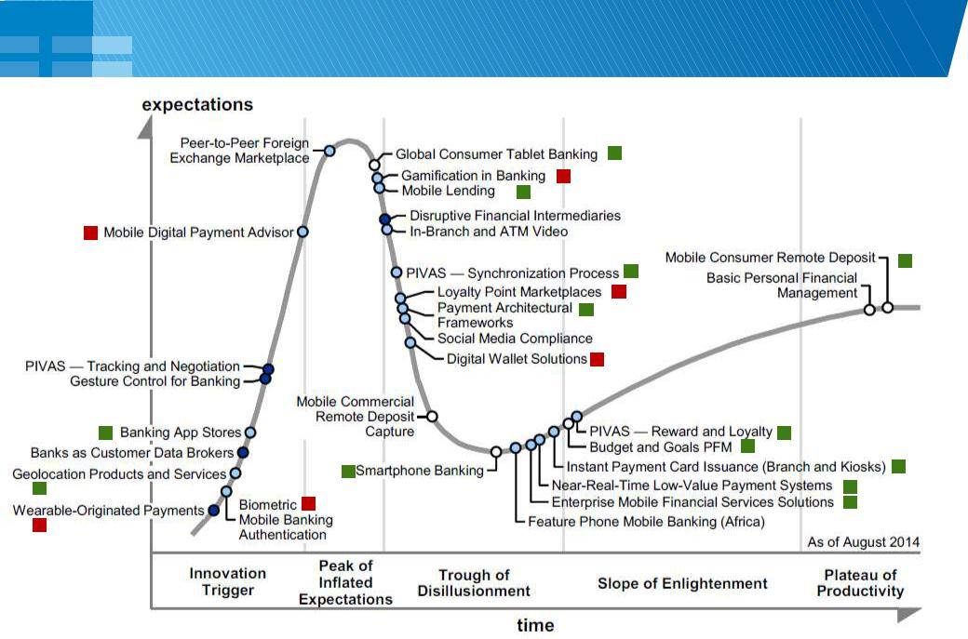**Gartner Hype Cycle for Digital Banking (2014)**



8

|  | ***TCS Actively Involved*** |  | ***Involved in POCs*** |
| --- | --- | --- | --- |
|  |  |



**TCS Digital Reimagination™**

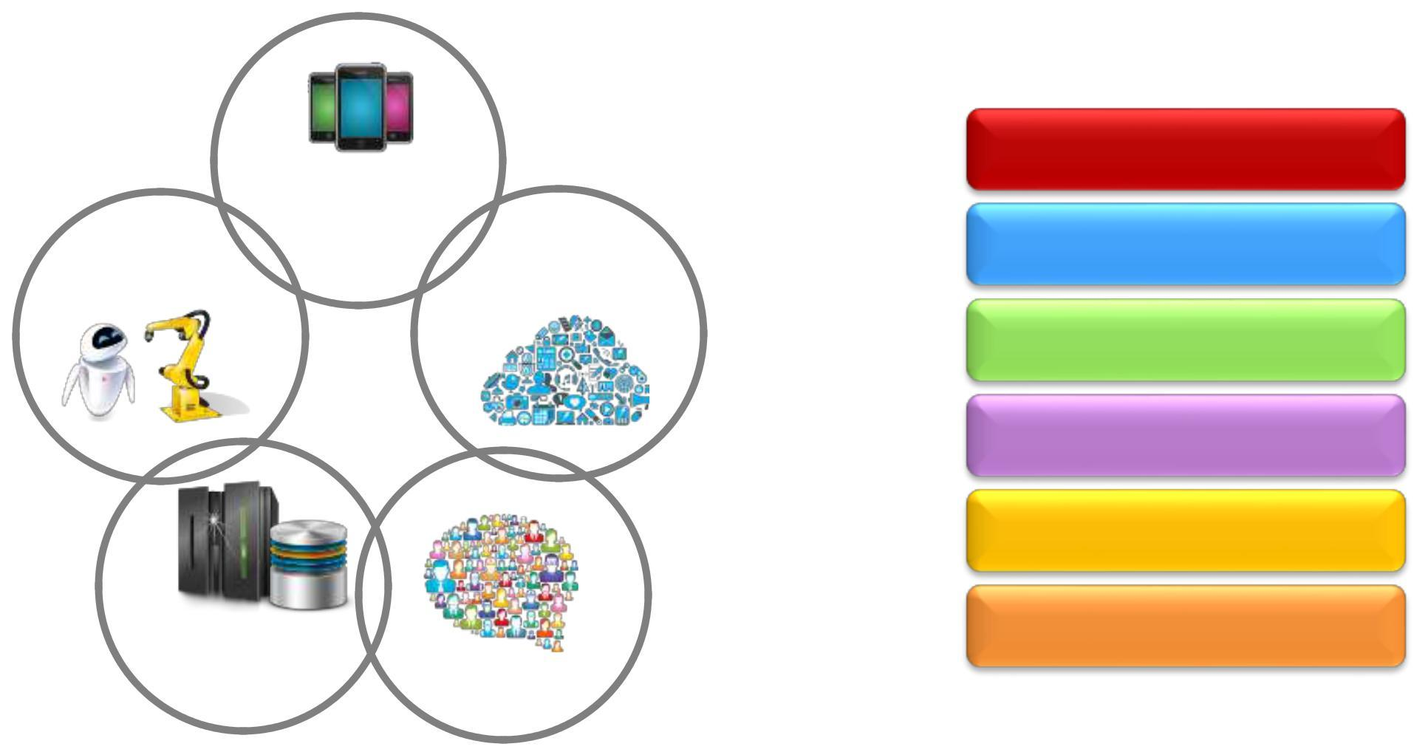

**MOBILITY &**

**PERVASIVE AI & COMPUTING**

**ROBOTICS**

**CLOUD**

| **BIG DATA** |  |
| --- | --- |
| **ANALYTICS** | **SOCIAL MEDIA** |
|  |



**Business Models**

**Products & Services**



**Customer Segments**

**Channels**

**Business Processes**

**Workplaces**

9

**Financial institutions leveraging Digital forces**



**Business Models**



**Products &**

**Services**



**Customer**

**Segments**



**Channels**



**Business**

**Processes**



**Workplace**



| UK: P2P evolving into | Australia: 3rd Party Developer | US: Social score for |
| --- | --- | --- |
| ecosystem, Crowdsourcing for app | Underwriting, Product |
| Money Movement |
| development | configuration |
|  |
| US: Servicing thru |  | US: Contextual Offer |
| Africa, India: Mobile Money | lifecycle management |
| Twitter and Facebook |
|  | thru Twitter, Facebook |
|  |  |



| LATAM: Mobile based | US: Life Style and Life Stage based | Europe, Canada: Digital |
| --- | --- | --- |
| Financial Inclusion | Products (predictive, machine |
| only banks for Netizens |
| solutions | learning) |
|  |
| US: Omni Channel and | US: End to end Ownership Circle | Australia, US: Branch |
| Multi modal | Digitization (systems, |
| on mobile (Car, Home) |
| experience | peripherals) |
|  |
| US: Omni Channel and | US, Europe: Real time credit quote | Australia: Document |
| Multi modal |
| & approvals (loans, mortgage) | Management on Cloud |
| experience |
|  |  |
| US: Advisory apps for | US, Australia: Mobile Doc Cloud | US, India: Predictive |
| Analytics to reduce |
| Financial Advisors | for instant access to information |
| attrition |
|  |  |



10



**Next Chapter : 2**

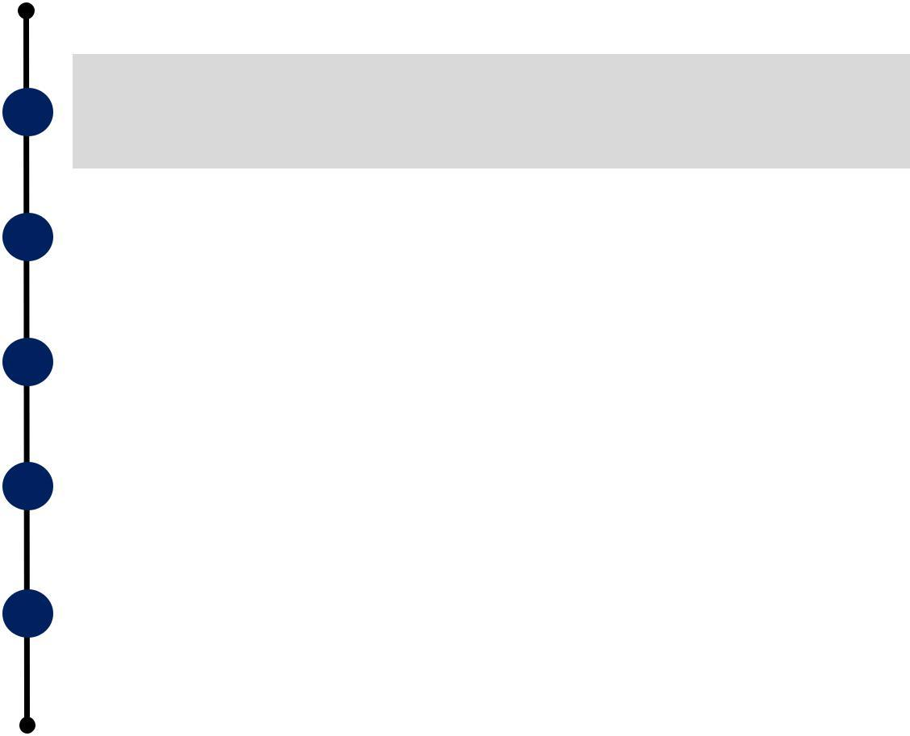

**Introduction**



**Customer**



**Banking Digitally**



**Channel Transformation**



**Effects on Retail LoBs**



11



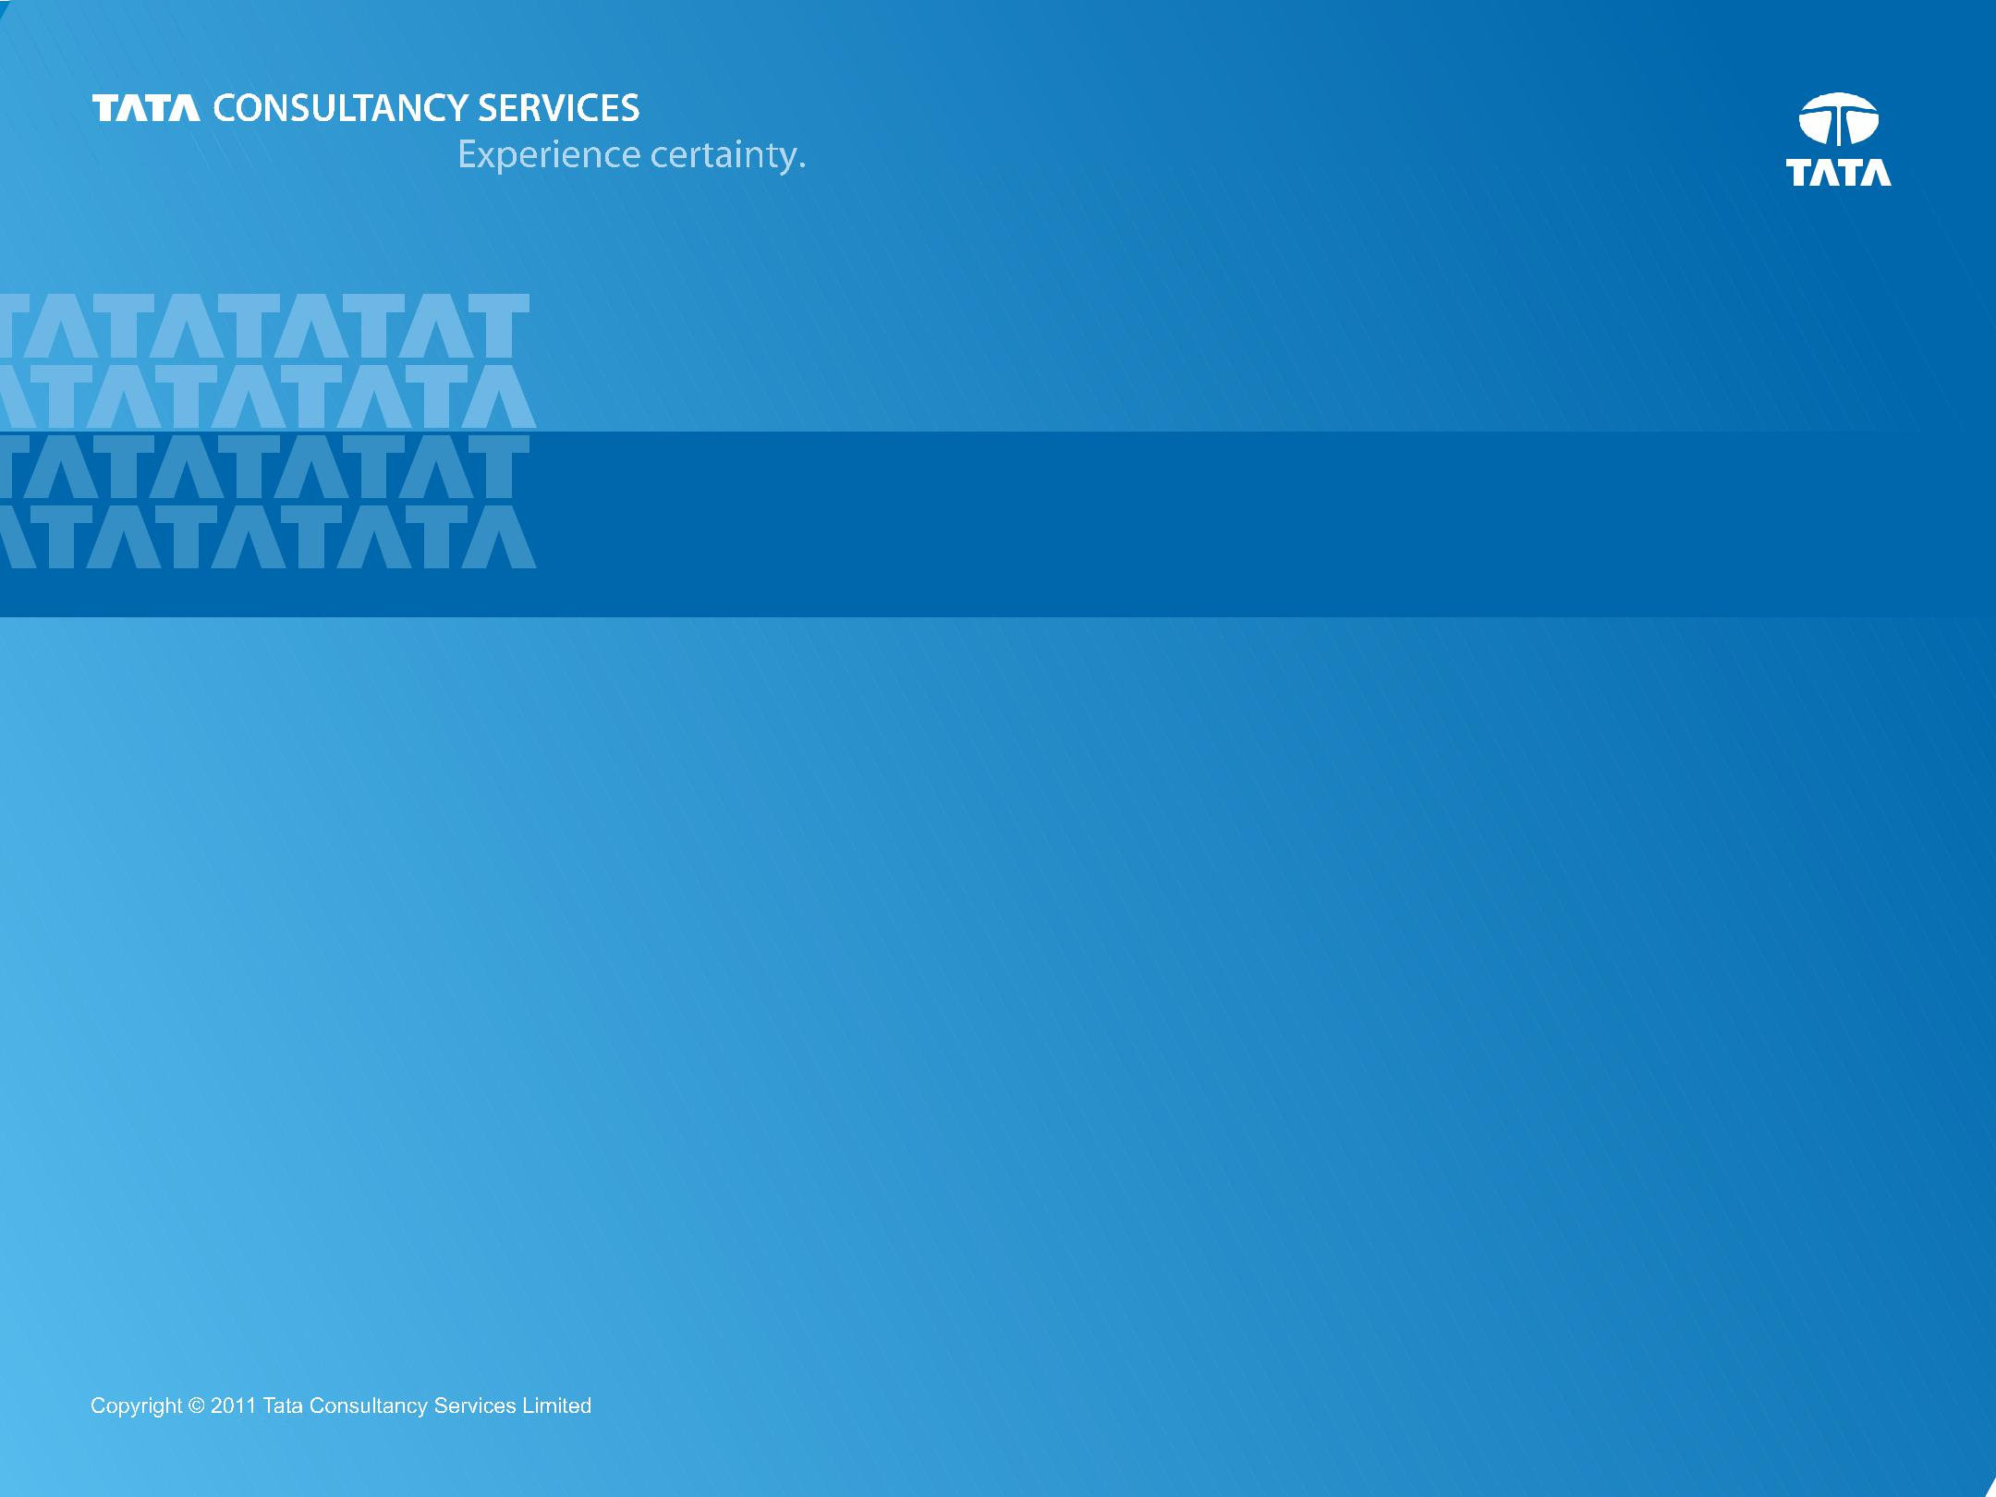

**THANK YOU**

**Prepared : October, 2014**

12